Investigation of Suspicious Mouse Movement and Possible Credential Attack
Organization: MahCyberDefense SOC

Findings
- The user, Ryan Adams, reported suspicious mouse movement on October 15, 2025 at 13:00 UTC.
- Splunk logs revealed 158 failed logon attempts (EventCode 4625) from internal IP 172.16.0.184 targeting multiple accounts on FRONTDESK-PC1.
- Several successful logons (EventCode 4624) for Ryan.Adams were also logged from 172.16.0.184 shortly before the reported anomaly.
- No follow-up evidence of compromise (process creation, PowerShell, RDP, scheduled tasks, malware indicators).
- Activity suggests a credential attack/brute-force attempt, not a confirmed remote compromise.

Investigation Summary
On October 15, 2025, Ryan Adams, a local administrator at a small dental clinic, reported that his mouse was moving on its own around 13:00 UTC, raising suspicion of unauthorized remote access.
Splunk analysis showed that between 12:52 UTC and 12:55 UTC, an internal host (172.16.0.184) attempted over 150 failed logons (mostly Logon Type 3-network logons) against several accounts, including Ryan's. A few attempts succeeded, but no evidence of malicious activity followed the logons.
No RDP sessions, PowerShell commands, process creations, or remote access tools were detected in the logs. Thus, while the authentication activity is clearly suspicious, no technical evidence confirms an active compromise or remote-control session.
The mouse movement may have been coincidental or the result of a method not captured by current telemetry.

Who, What, When, Where, Why, How
Who
- Affected User is Ryan Adams
- Target System is FRONTDESK-PC1
- Source of Activity is from 172.16.0.184 (internal host)
- Accounts targeted include administrator, guest, andrew.henderson, jayden.gray, ryan.adams

What
- A high volume of failed and some successful logon attempts.
- User-reported suspicious mouse movement.
- No indicators of remote execution or compromise found.

When
- Suspicious activity occurred:
2025-10-15 12:52:12–12:55:20 UTC
- User reported anomaly at:
2025-10-15 -13:00 UTC
- No evidence that the activity continued after that timeframe.

Where
- The incident occurred on endpoint FRONTDESK-PC1.
- Logon attempts originated from 172.16.0.184 within the internal LAN.

Why
Few explanations come to mind which include possible,
- Credential guessing or automated password attack from another internal device.
- Misconfigured software or service authenticating repeatedly.
- User unintentionally triggering authentication attempts.

How
- The attacker or system attempted repeated logons using Windows network authentication (Logon Type 3).
- Some attempts were successful, but nothing executed afterward.
- No persistence, malicious commands, or remote tools were detected.

MITRE Assessment
This incident strongly aligns with credential brute-force attempts and attempted misuse of valid credentials, with no confirmed post-authentication compromise.

Recommendations
- Reset all affected passwords, prioritizing privileged accounts especially, administrator accounts and Ryan Adams credentials.
- Enforce MFA on all privileged and high-risk accounts to prevent future unauthorized access.
- Implement account lockout policies to limit repeated failed logon attempts and reduce brute-force risks.
- Set up automated monitoring by creating a Splunk alert to detect unusual spikes in failed logons (EventCode 4625).
- Provide user awareness training,
- Reinforce the importance of reporting suspicious system behaviour.
- Encourage immediate reporting of unexpected mouse, keyboard, or remote-control-like activity.

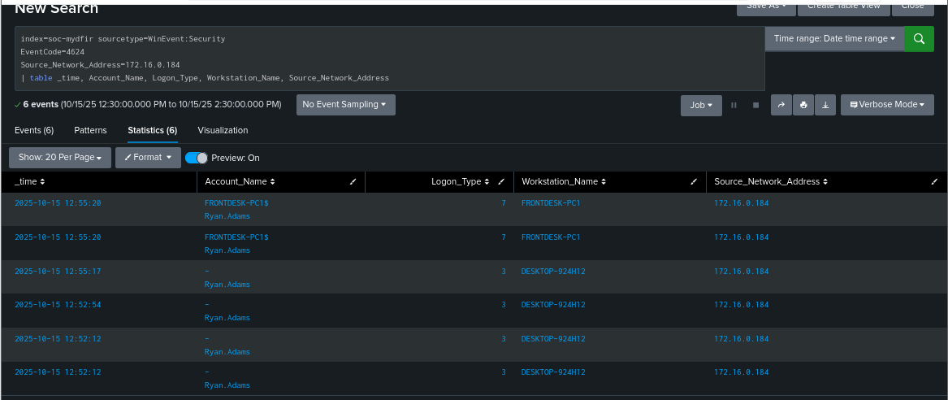
Figure 1: Showing Successful Logons with no Remote Interactive logon

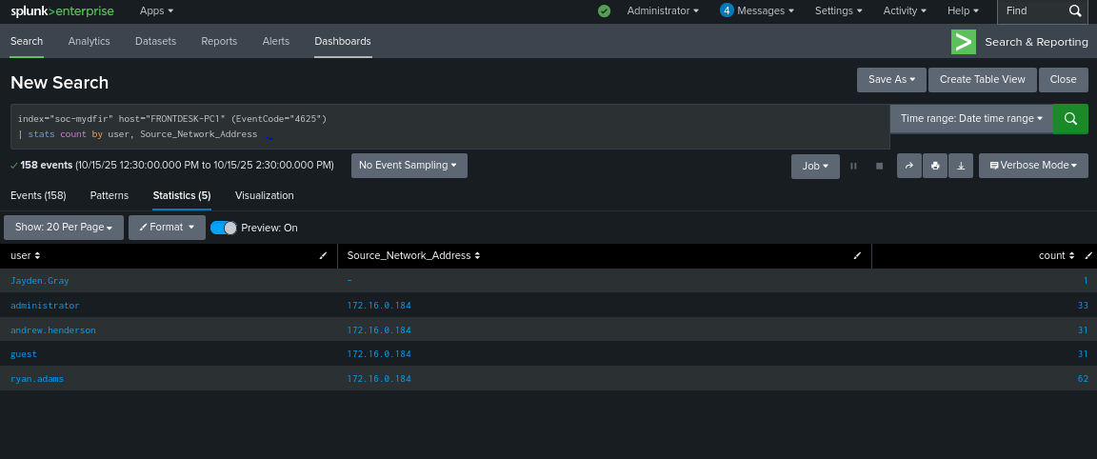
Figure 2: Showing Failed Logons or possible Brute Force Attack

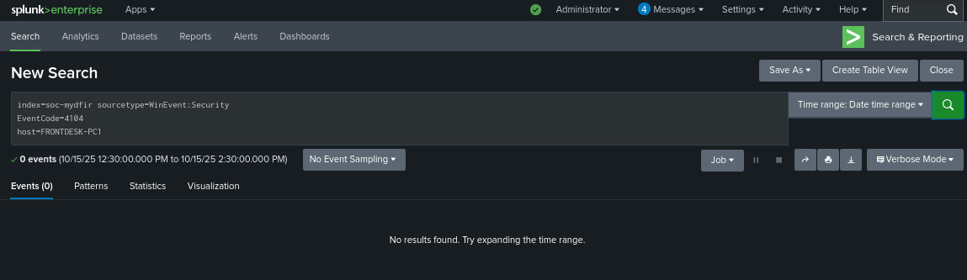
Figure 3: Showing no Powershell Actvity

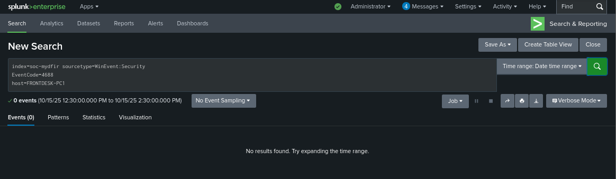
Figure 4: Showing no Process Activity

